**UX Design Proposal for Portfolio Website**  
  
**Project Overview**  
-Project Title: Portfolio Website  
-Objective: To design a visually appealing and user-centered portfolio website that effectively showcases our skills, projects, and experiences, enhancing our professional visibility and engagement with potential clients and employers.   
  
--- -----------------------------------------------------------------------------------------  
  
**Target Audience**  
The primary users of this portfolio website include:  
- Potential Clients: Small to medium-sized business owners looking for creative services such as **web design, translation , lawyer workings or ChemBio education.**  
- Industry Peers: Professionals within the creative industry seeking collaboration or networking opportunities.  
- Recruiters: Human resources professionals looking for candidates with strong portfolios and unique skills.   
  
--- --------------------------------------------------------------------------------------------------  
  
**Information Architecture**  
1. Sitemap:  
  - Home  
  - About Us  
  - Portfolio  
    - Web Design  
    - ChemBio coder  
    - lawyer / translation   
**- Services  
  - Pricing  
  - Contact** 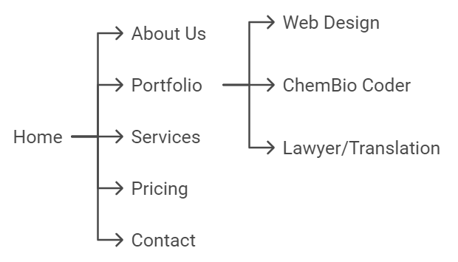

**2. Content Strategy:** Each section will focus on showcasing our best work, with case studies in the portfolio that highlight the process and outcomes of key projects. The “About Us” section will tell our story and showcase our team’s expertise and values.   
  
--- -------------------------------------------------------------------------------------------

**Wireframing and Prototyping**

- Low-Fidelity Wireframes: Initial wireframes for the homepage, portfolio, and contact pages have been created. The homepage will feature a hero image, a brief introduction, and links to key portfolio pieces.   
  
- High-Fidelity Prototypes/prototyping: Interactive prototypes are being developed using Figma to visualize the design elements and layout. These prototypes will include brand colors, typography, and placeholder content to simulate the final look and feel.

[prototyping](https://app.visily.ai/projects/3fd69269-d494-4087-994a-04fdf4ac4939/boards/1335964/presenter?play-mode=All%20screens) 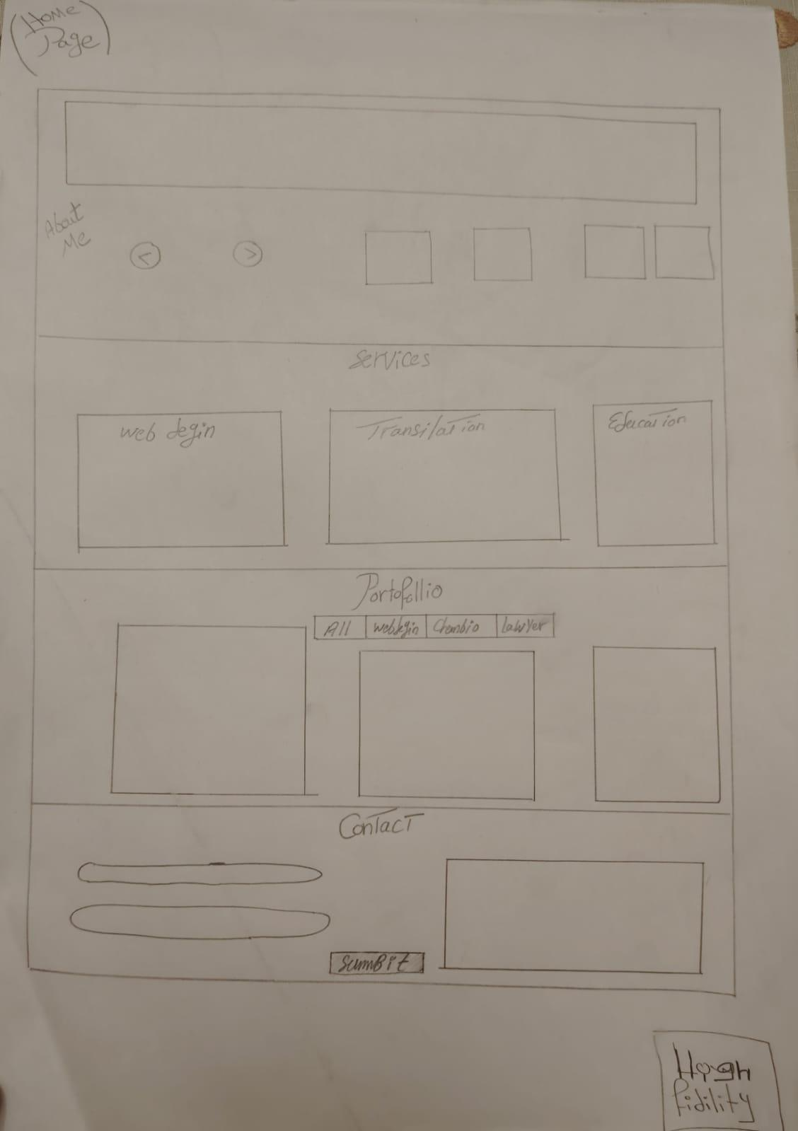

[Home page prototyping](https://www.figma.com/design/mH1Mrwyw9B0rZRzle8k8ks/Untitled?node-id=0-1&t=CMxEMStf3rkSsHSo-1)

This high fidelity will focus on the homepage, portfolio navigation, and contact forms.  
----------------------------------------------------------------------------------------------   
  
**Visual Design**  
**- Brand Alignment:** The visual identity will align with our brand, featuring a clean and modern aesthetic. We will use a color palette of deep blue, soft gray, and white, with high-quality images of our work.  
- Balance Aesthetics and Functionality: The design will emphasize usability, ensuring that users can easily navigate through the portfolio while enjoying a visually engaging experience.   
  
----------------------------------------------------------------------------------  
  
**Conclusion**  
This proposal outlines a comprehensive **UX strategy for our portfolio website**, emphasizing a user-centered approach and collaboration. By focusing on understanding user needs and iterating based on feedback, we aim to create a standout online presence that effectively showcases our skills and projects.